Name : Vugomi Rhulani Mathye
Student ID : C11/26/FCDF/17157
International Cybersecurity and Digital Forensics Academy (ICDFA)
Basic Computer Skills for Digital Forensics
Lab 1B: PC System Fundamentals, Disk Sectors and Partition Analysis
Student Practical Laboratory Manual

1. Lab Overview
This lab introduces the basic computer system knowledge required for beginner digital forensic work. Students will identify system hardware and software information, map where digital evidence can exist, calculate disk and partition sizes from sector information, inspect partition layout using safe read-only commands, explain the boot process, and identify file systems used by common operating systems.
PC System Fundamentals, Disk Sectors and Partition Analysis

The objective of this laboratory exercise is to:
- Identify computer hardware and software components.
- Determine possible digital evidence sources.
- Understand disk sectors and partition structures.
- Calculate partition sizes using sector information.
- Examine disk partition layouts using read-only methods.
- Explain the PC boot process.
- Identify common file systems used by operating systems.

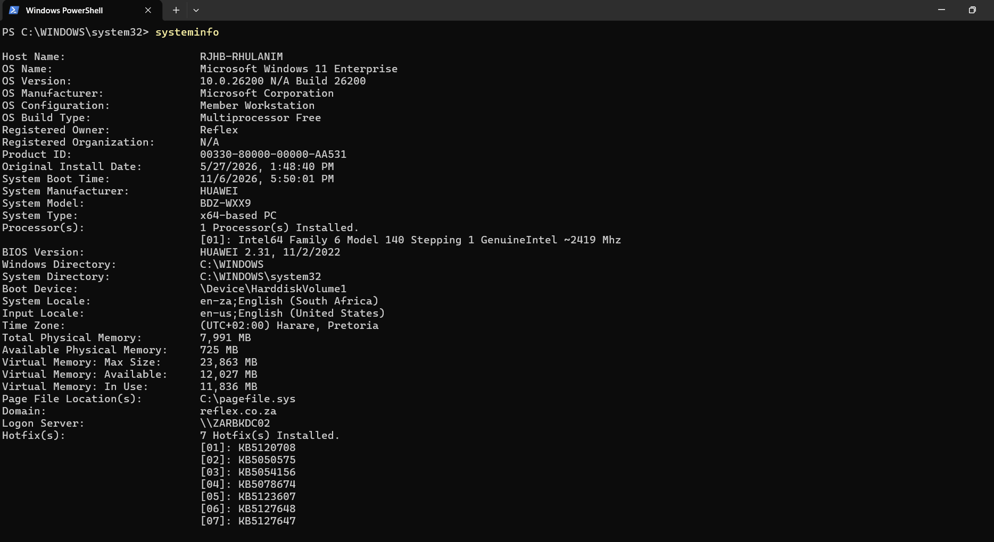
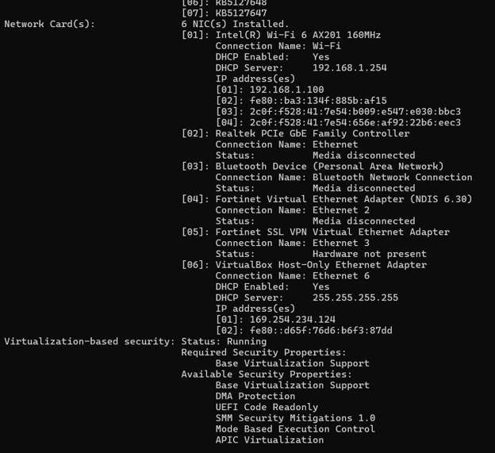
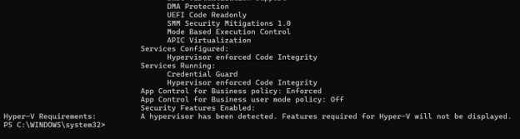
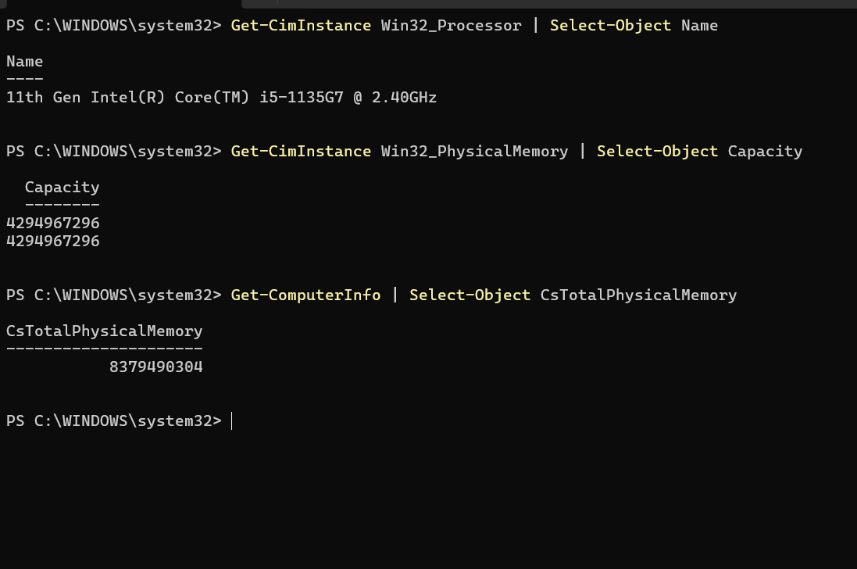

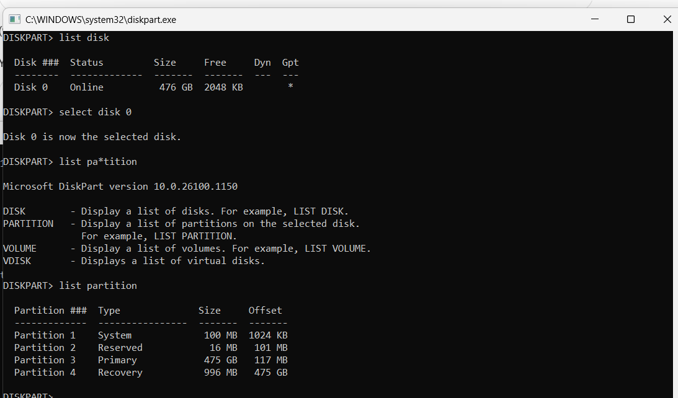
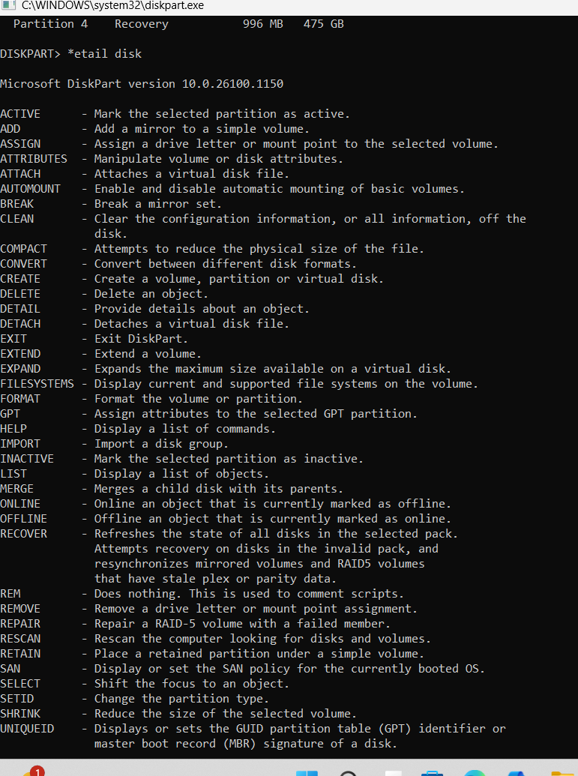
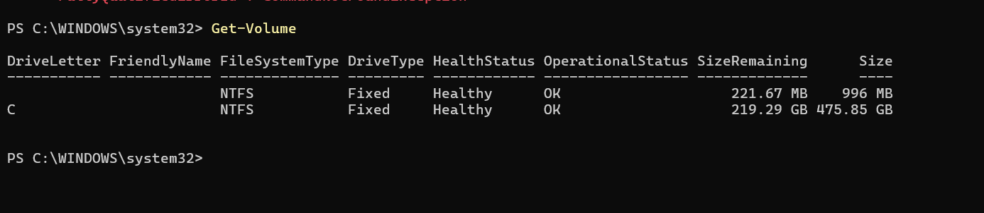

During this laboratory exercise, system hardware, storage devices, partitions, and file systems were examined using read-only commands and utilities. Analysis revealed that Disk 0 has a capacity of 476 GB and uses the GPT partitioning scheme. Four partitions were identified: System, Reserved, Primary, and Recovery. The Windows installation uses the NTFS file system. These observations provide foundational knowledge of computer systems, storage structures, and file systems relevant to digital forensic investigations.
Lab 2
Learning Outcome | Evidence
Identify PC hardware and OS information | systeminfo / PowerShell system information
Use safe read-only commands | diskpart, list disk, list partition
Calculate/understand partitions | Disk 0 = 476 GB, partitions identified
Explain PC boot process | Written explanation required
Compare MBR and GPT | GPT confirmed by * in GPT column
Identify file systems | Get-Volume showing NTFS
Professional evidence-style report | Screenshots + analysis

Program vs Process vs Thread
- Technical difficulties
  - OS: different OS types, versions, complexity of OS
  - Applications: many applications, different versions of applications
  - Hardware: CPU, GPU, camera
  - Ever-advancing technology: e.g., database changes, Mobile/IoT, EV car
- A complex and connected world
  - IoT devices: Alex, Camera, Fitbit, Smart Phone
- Information explosion
  - too much information, different types of evidence
  - how to collect, analyze, and validate them systematically?
- Computer forensics is NOT only a computer science discipline
  - criminal justice, law, computer science, security

Program -A program is a file containing instructions stored on disk, such as Microsoft Word or Google Chrome.
Process -A process is a running instance of a program in memory. When a user starts Google Chrome, the operating system creates one or more processes.
Thread -A thread is the smallest unit of execution within a process. A process may contain multiple threads running simultaneously.
Forensic Importance -Investigators analyze processes and threads because they reveal what was running on a system at a particular time and may contain evidence in memory.

Why Computer Forensics Is Technically Difficult

Factors include:
- Operating systems generate large amounts of logs.
- Applications create temporary and hidden data.
- Hardware differs between systems.
- External devices may contain evidence.
- Modern storage capacities generate large data volumes.

PC Boot Process
- Power button is pressed.
- CPU receives power and begins execution.
- BIOS/UEFI performs POST (Power-On Self-Test).
- Firmware locates a bootable device.
- Boot manager loads.
- Operating system kernel is loaded into memory.
- System services start.
- User login screen appears.
- User gains control of the operating system.

MBR vs GPT
Feature | MBR | GPT
Max Partitions | 4 Primary | 128+
Max Disk Size | 2 TB | 9.4 ZB
Firmware Type | Legacy BIOS | UEFI
Redundancy | No | Yes
Modern Standard | No | Yes
Observation from your lab
Disk 0 uses GPT as indicated by the asterisk (*) in the GPT column of the DiskPart output.
Common File Systems
File System | Operating System
FAT/FAT32 | Older Windows, USB drives
NTFS | Windows
ext3/ext4 | Linux
| XFS | Linux Enterprise Systems | | JFS | IBM/Linux | | btrfs | Modern Linux | | HFS+ | Older macOS |
Observation from your system
The primary Windows volume (C:) uses the NTFS file system.
Conclusion
This laboratory exercise introduced fundamental concepts required for digital forensic investigations. Hardware, storage devices, partitions, and file systems were examined using read-only techniques. Disk analysis revealed a 476 GB GPT-formatted disk containing System, Reserved, Primary, and Recovery partitions. The Windows operating system uses NTFS as its primary file system. Understanding these concepts provides a foundation for future forensic acquisition and analysis tasks.
Lab 3
Rule | Compliance
No partition modifications performed | ✓ Complied
No formatting or deletion of data | ✓ Complied
Read-only commands used | ✓ Complied
DiskPart used for viewing only | ✓ Complied
File system information collected safely | ✓ Complied
Screenshots documented findings | ✓ Complied

The examination followed the fundamental forensic principle of preserving evidence integrity. Information was viewed and documented without altering the state of the system. This ensures that findings remain repeatable, verifiable, and suitable for forensic investigation and reporting.

6. Lab Scenario
You are a junior digital forensic trainee asked to prepare an initial system profile for a computer that may later be used in a forensic investigation. Your task is to document the system safely, identify possible evidence layers, inspect disk and partition details, calculate partition sizes, explain the boot process, and identify file systems without altering the computer.

Part A - System Identification and Evidence Layer Mapping
In this section, you will identify the major computer system layers and explain how each layer can produce forensic evidence.

A1. Capture basic system specification
- On Windows, open System Information by pressing Windows + R, typing msinfo32, and pressing Enter.
- Capture a screenshot showing OS Name, Version, System Type, Processor, BIOS Mode, Installed Physical Memory, and Secure Boot State if available.
- Also run the command below in Command Prompt and capture the first page of output.
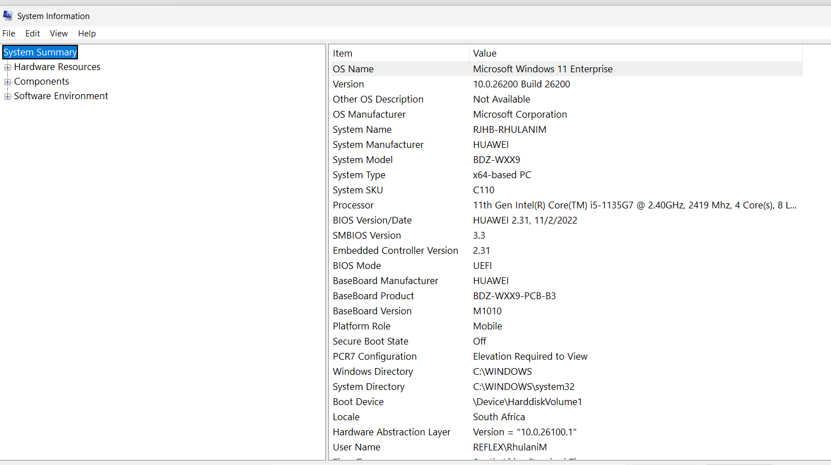

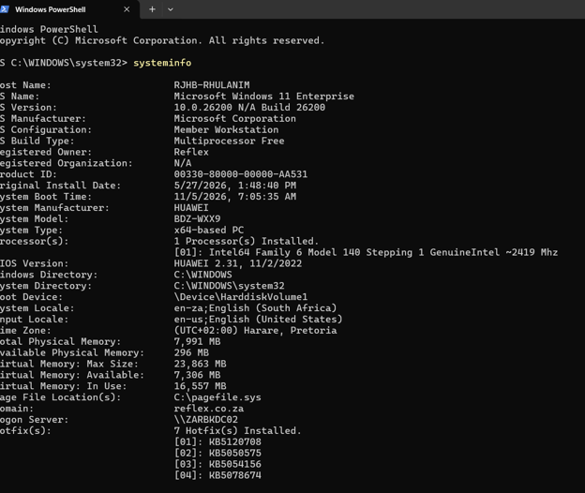

A2. Capture storage information
- Open Command Prompt or PowerShell.
- Run one of the command sets below. Capture screenshots of storage model, size, partitions, and file systems.
- If a command is not supported on your system, use the alternative command.

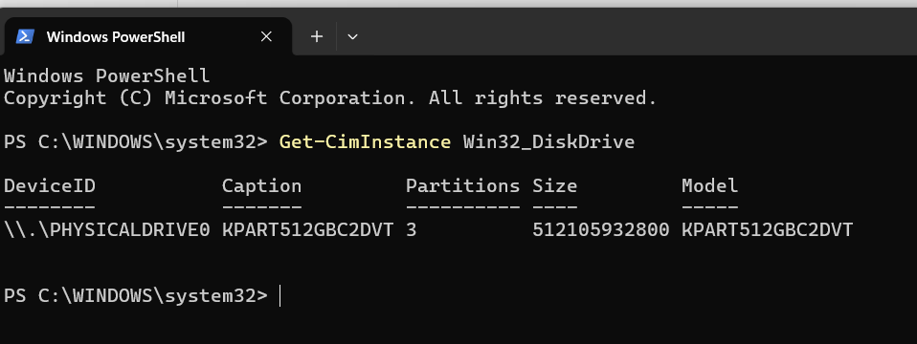

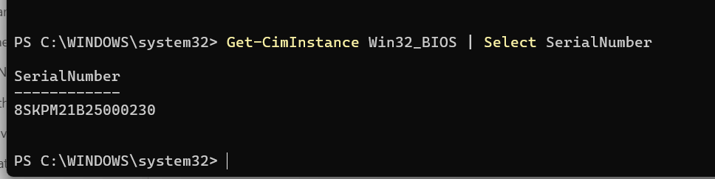
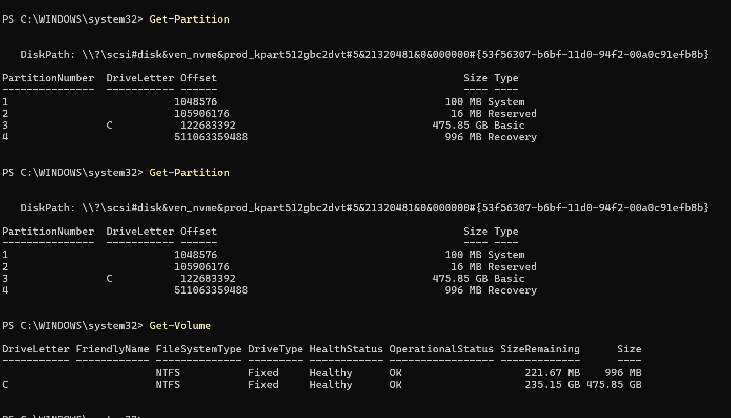

A3. Map evidence sources to system layers
- Create a table in your report showing at least five system layers/sources and the type of evidence that can be generated from each one.
- Use this guide: User activities = Applications + Operating System + Disk/Memory.
- Explain why evidence may exist in more than one layer.

Layer / Source | - Example Evidence | - Where It May Be Found | - Why It Matters
User Layer | - Opened files, searched terms, typed usernames, accessed websites | - Recent Files, browser history, command/shell history | - Links a user's actions directly to activity on the system.
Application Layer | - Office document metadata, browser cache, email records, chat logs | - Application folders, databases, browser profiles | - Shows what software was used and how evidence was created or modified.
Operating System Layer | - Event logs, user accounts, login records, installed programs | - Windows Event Viewer, Registry, Linux /var/log, user profiles | - Provides evidence of system events, account usage, and configuration changes.
Disk Layer | - Deleted files, file fragments, partition data, file system metadata | - NTFS/FAT file systems, partitions, unallocated space | - Allows recovery of deleted evidence and reconstruction of timelines.
Memory / Process Layer | - Running processes, malware, network connections, process IDs (PIDs) | - RAM captures, process lists, memory dumps | - Reveals live system activity that may never be written to disk.

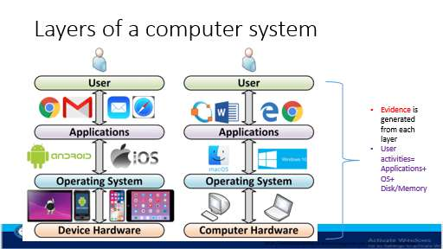

A3. Map evidence sources to system layers
- Create a table in your report showing at least five system layers/sources and the type of evidence that can be generated from each one.
- Use this guide: User activities = Applications + Operating System + Disk/Memory.
- Explain why evidence may exist in more than one layer.
Layer / Source | Example Evidence | Where It May Be Found | Why It Matters
User layer | Opened files, searched terms, typed usernames | Recent files, browser history, shell history | Links user action to system activity
Application layer | Office document metadata, browser cache, chat logs | Application folders and databases | Shows what software created or used evidence
OS layer | Event logs, installed programs, user profiles | Windows logs, registry, Linux /var/log | Shows system events and account activity
Disk layer | Deleted files, file fragments, partitions | File system and unallocated space | Supports recovery and timeline analysis
Memory/process layer | Running malware, PIDs, network connections | RAM capture, process list | Shows live system behavior

Part B - Program, Process and Thread Investigation
This section links the slide concept of program, process, and thread to forensic observation.

B1. Observe running processes
- Open Task Manager on Windows, or use Command Prompt/PowerShell.
- Capture a screenshot showing running processes.
- Select three processes and record their process names, PID values, and likely purpose.
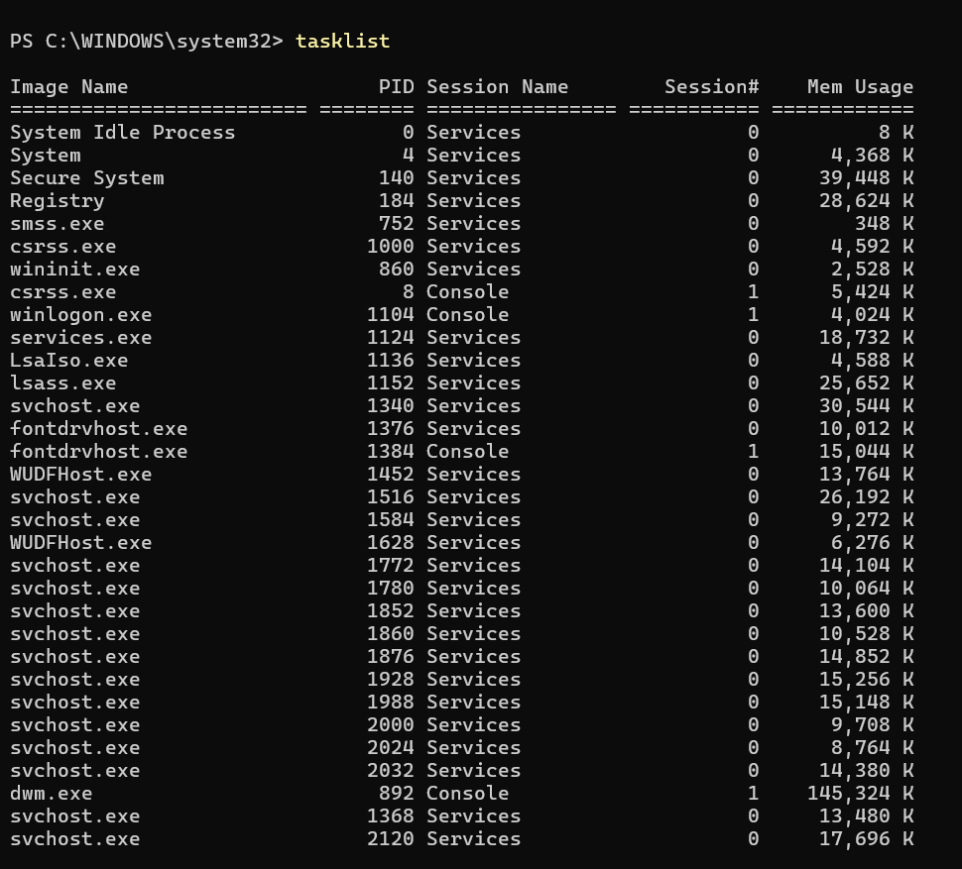
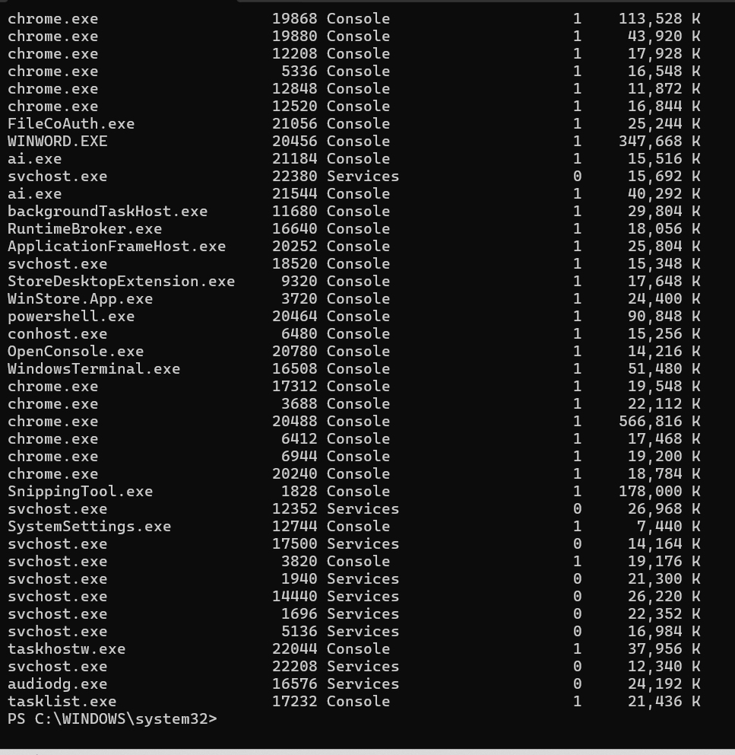

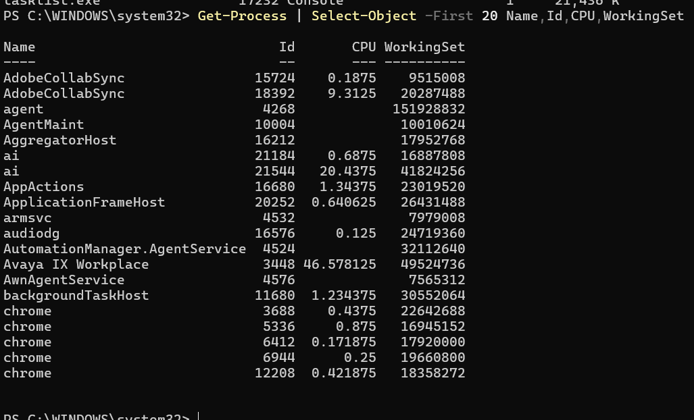

Part C - Disk Sector and Disk Size Calculation
Key formula
Disk or partition size = number of sectors x bytes per sector. To convert bytes to GB, divide by 1024 x 1024 x 1024.

C1. Reproduce the slide calculation
Use the values from the slide to calculate the total disk size: sectors per track = 400, heads = 12, cylinders = 17000, and bytes per sector = 512.
Item | Formula / Value | Answer
Total sectors | 400 x 12 x 17000 | 81,600,000 sectors
Total bytes | 81,600,000 x 512 | 41,779,200,000 bytes
Kilobytes | 41,779,200,000 / 1024 | 40,800,000 KB
Megabytes | 40,800,000 / 1024 | 39,843.75 MB
Gigabytes | 39,843.75 / 1024 | 38.91 GB

C2. Calculate your own disk or partition size
- Use your partition table or disk details to identify at least two partitions.
- For each partition, record the start sector, number of sectors, sector size, and file system where available.
- Calculate the size of each partition in GB using the formula above.
Your calculation must be shown step-by-step. Screenshots alone are not enough

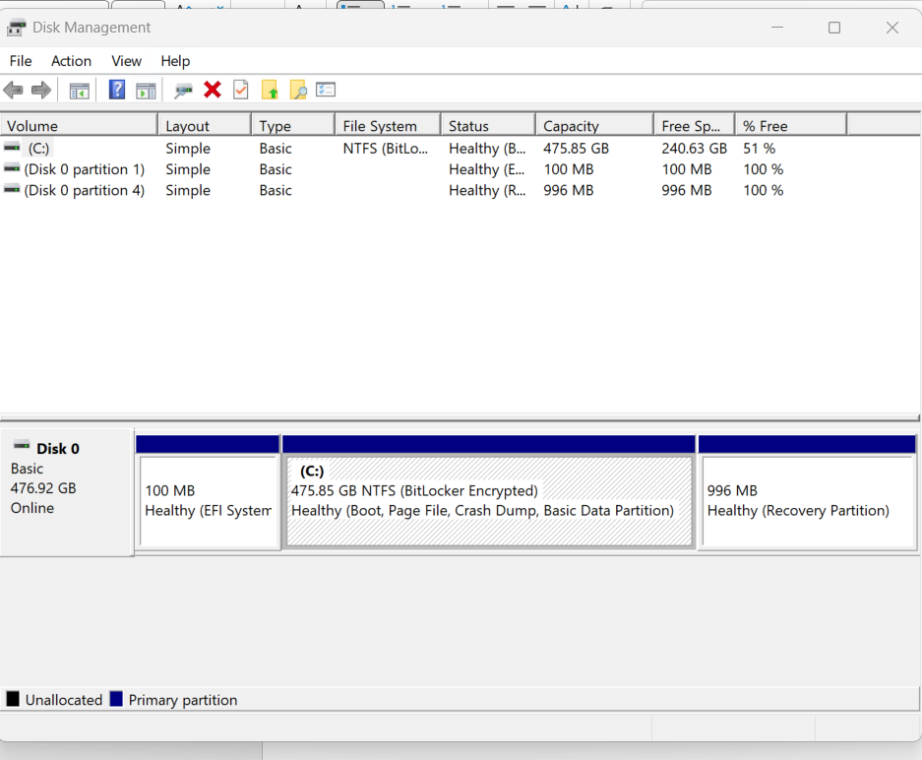
The Disk Management screenshot shows: (Disk 0 with EFI Partition, C: Partition, and Recovery Partition)
Partition 1: C: Drive (475.85 GB)
Formula:
$$\text{Sector Count}=\frac{\text{Partition Size in Bytes}}{512}$$
First calculate the bytes:
$$475.85×1024×1024×1024=510,940,790,374\text{ bytes}$$
Calculate sector count:
$$510,940,790,374÷512=998,907,794\text{ sectors}$$
Using the lecturer's formula:
$$998,907,794×512÷1024÷1024÷1024 \\ =475.85\text{ GB}$$
Answer: 475.85 GB

Partition 2: Recovery Partition (996 MB)
Convert to GB first:
$$996÷1024=0.97265625\text{ GB}$$
Calculate bytes:
$$0.97265625×1024×1024×1024=1,044,676,608\text{ bytes}$$
Calculate sector count:
$$1,044,676,608÷512=2,040,384\text{ sectors}$$
Using the formula:
$$2,040,384×512÷1024÷1024÷1024 \\ =0.97\text{ GB}$$
Answer: 0.97 GB

Partition 3: EFI System Partition (100 MB)
Convert to GB:
$$100÷1024=0.09765625\text{ GB}$$
Calculate bytes:
$$100×1024×1024=104,857,600\text{ bytes}$$
Calculate sector count:
$$104,857,600÷512=204,800\text{ sectors}$$
Using the formula:
$$204,800×512÷1024÷1024÷1024 \\ =0.0977\text{ GB}$$
Answer: 0.10 GB
Summary Table
Partition | Sector Count | Sector Size | File System | Calculation | Size
C: Drive | 998,907,794 | 512 bytes | NTFS | 998,907,794 × 512 ÷ 1024 ÷ 1024 ÷ 1024 | 475.85 GB
Recovery | 2,040,384 | 512 bytes | Recovery | 2,040,384 × 512 ÷ 1024 ÷ 1024 ÷ 1024 | 0.97 GB
EFI System | 204,800 | 512 bytes | EFI System | 204,800 × 512 ÷ 1024 ÷ 1024 ÷ 1024 | 0.10 GB

Conclusion: Using the formula Partition Size in GB = Sector Count × 512 ÷ 1024 ÷ 1024 ÷ 1024, the C: partition is 475.85 GB, the Recovery partition is 0.97 GB, and the EFI System partition is 0.10 GB, which matches the sizes displayed in Disk Management.

Part D - Safe Partition Table Inspection
Choose either Windows or Linux. You may do both for extra practice. You must not modify the disk.

D1. Windows method - Disk Management, PowerShell and DiskPart
- Open Disk Management by pressing Windows + R, typing diskmgmt.msc, and pressing Enter.
- Capture a screenshot showing your disk layout and visible partitions.
- Open PowerShell as normal user or administrator if required and run the safe read-only commands below.
- Open Command Prompt as administrator and run DiskPart only for listing disks and partitions. Do not run create, delete, clean, format, active, or convert commands.

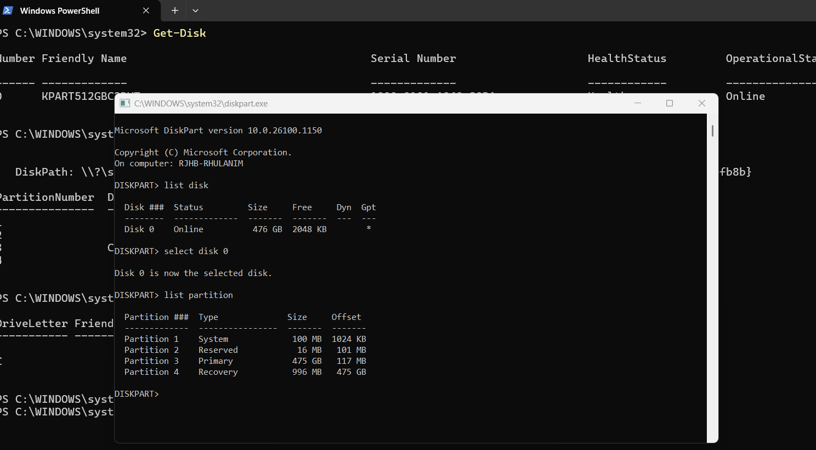

D2. Linux/Kali method - read-only inspection
- Open Terminal in your Linux/Kali VM or host.
- Run the commands below and capture screenshots showing disk, partition, size, and file system information.
- Do not run mkfs, fdisk write commands, parted write commands, dd write commands, or mount read-write commands for this lab.
lsblk -o NAME,SIZE,TYPE,FSTYPE,MOUNTPOINT
sudo fdisk -l
sudo parted -l
blkid
df -h

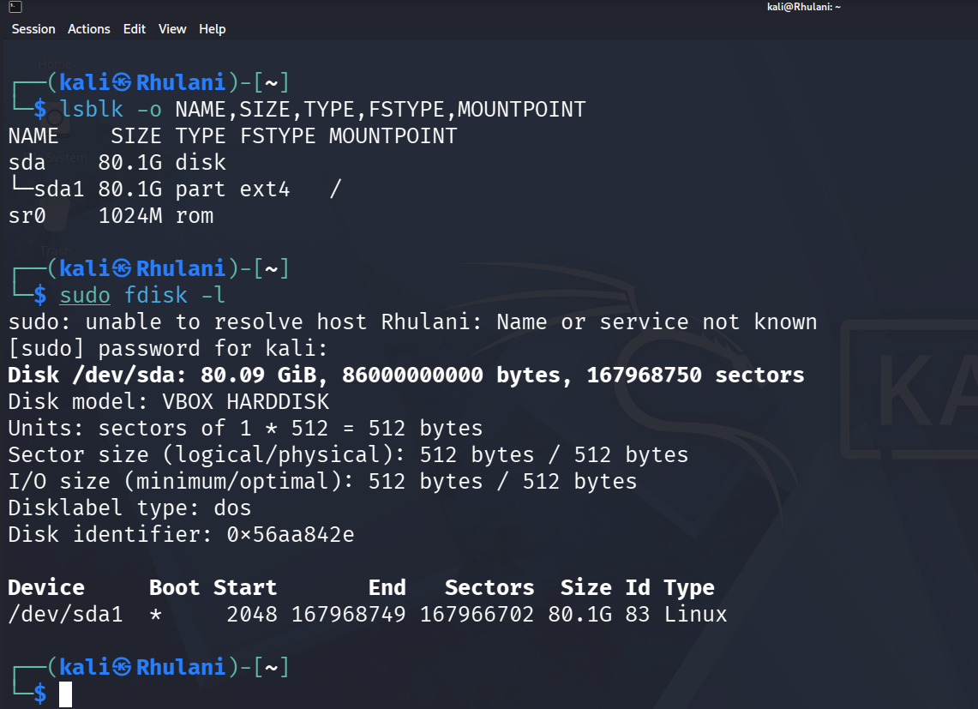

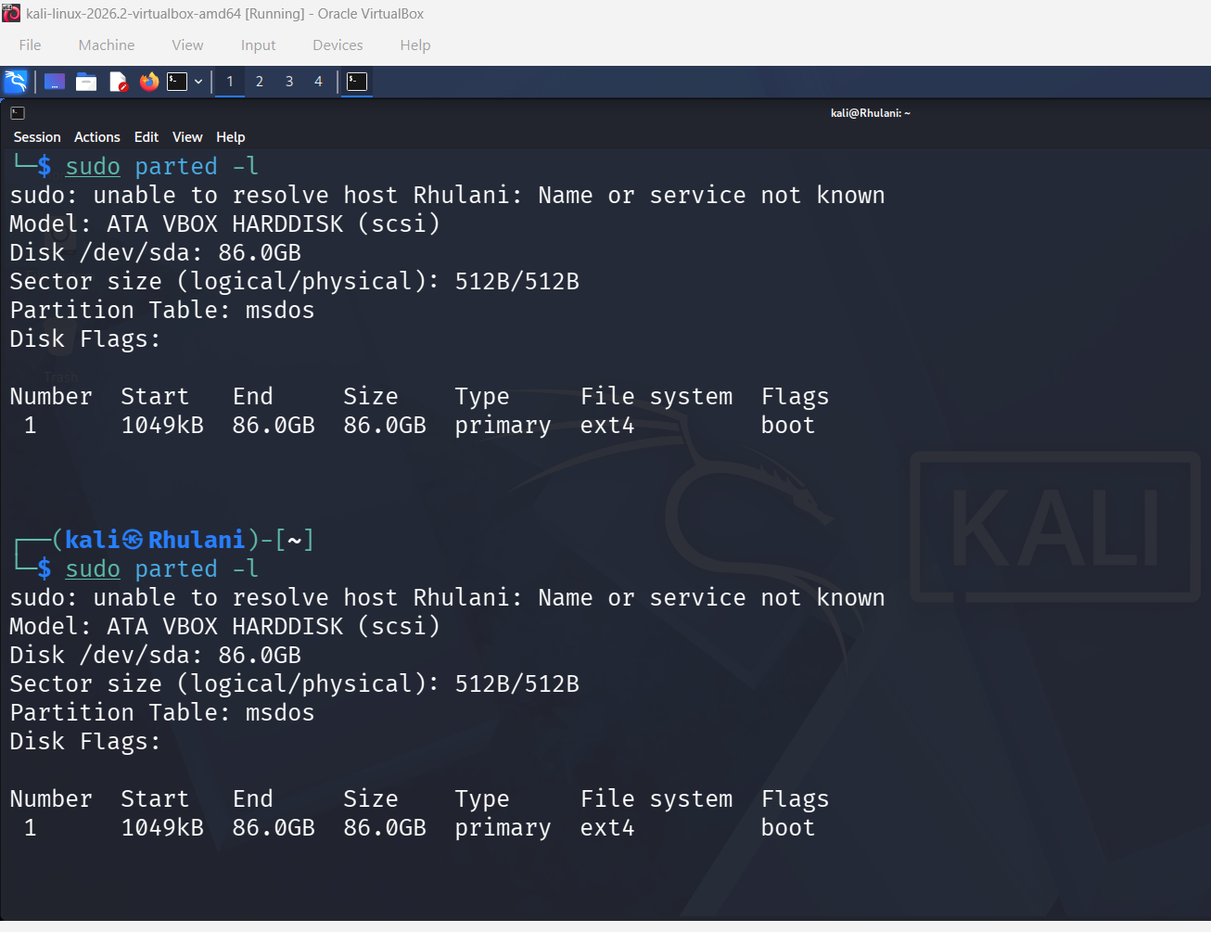

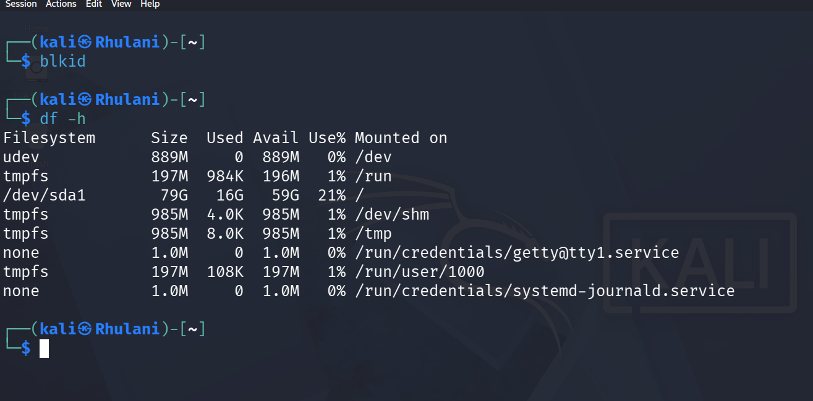

D3. Optional WinHex or forensic viewer method
- If your instructor permits, open the physical disk or disk image in a forensic/hex viewer in read-only mode.
- Navigate to sector 0 and capture the first sector where the MBR/protective MBR may be visible.
- Identify whether the disk appears to use MBR or GPT. If you cannot safely view this, skip the optional step.

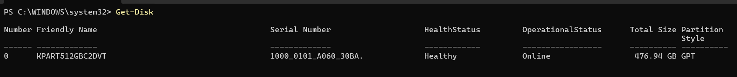

• Disk 0: KPART512GBC2DVT
• Size: 476.94 GB
• Partition Style: GPT

Disk Number | Friendly Name | Size | Partition Style
0 | KPART512GBC2DVT | 476.94 GB | GPT

The examined disk uses the GPT partitioning scheme. This was verified using the Get-Disk command, and a forensic viewer would be expected to show a Protective MBR in Sector 0 rather than a standard MBR partition table.

Part E - MBR, GPT and Boot Process Explanation

E1. Explain the boot process
- Create a simple flow diagram or numbered list explaining how a PC boots.
- Your explanation must include power-on, POST, BIOS/UEFI, CMOS/firmware settings, MBR/GPT or EFI boot records, boot loader/manager, kernel loading, and operating system control.
- State whether your own system uses BIOS/Legacy or UEFI based on system information evidence.
Power On
↓
POST (Power-On Self-Test)
↓
BIOS / UEFI Firmware
↓
CMOS / Firmware Settings
↓
MBR or GPT / EFI Boot Records
↓
Boot Loader / Boot Manager
↓
Operating System Kernel Loads
↓
Operating System Takes Control
- Power-On
  - When the computer is switched on, it begins the startup process.
- POST (Power-On Self-Test)
  - The computer performs POST to check that hardware components are functioning correctly.
- BIOS/UEFI Firmware
  - The boot sequence is controlled by the BIOS or UEFI firmware.
- CMOS/Firmware Settings
  - BIOS parameters and boot settings are stored in CMOS memory or firmware settings and determine how the system starts.
- MBR/GPT or EFI Boot Records
  - In BIOS systems, control passes to the Master Boot Record (MBR).
  - In UEFI systems, boot information is obtained from GPT and EFI boot records.
- Boot Loader/Manager
  - The MBR points to the boot record of the selected operating system.
  - The boot manager or boot loader prepares the operating system for startup.
- Kernel Loading
  - The operating system kernel loads the system files required for operation. The "boot" volume is used to load the actual operating system.
- Operating System Control
  - After the kernel loads successfully, the operating system takes control of the computer and presents the user interface.
E2. Compare MBR and GPT

Feature | MBR | GPT
Age / Design | Older partitioning system introduced in the 1980s. | Modern partitioning system used with UEFI systems.
Size Limitation | Supports disks up to approximately 2 TB. | Supports very large disks up to about 9.4 ZB,
Partition Information | Partition table and boot code are stored in the first sector (Sector 0). | Uses GPT headers and partition entries with backup copies.
Boot Method | Used mainly with Legacy BIOS systems. | Used mainly with UEFI systems
Recovery Capability | No backup partition table. | Stores backup GPT structures for recovery.
Forensic Issue | Damage to Sector 0 may affect interpretation of partitions. | Backup GPT structures can assist validation and recovery.

Part F - File System Identification and Interpretation
- Identify the file system used by at least two volumes or partitions on your system.
- For Windows systems, identify whether volumes use NTFS, FAT/FAT32, exFAT, or another file system.
- For Linux systems, identify whether partitions use ext4, XFS, btrfs, swap, or another file system.
- In your report, explain why a file system is important in digital forensics.
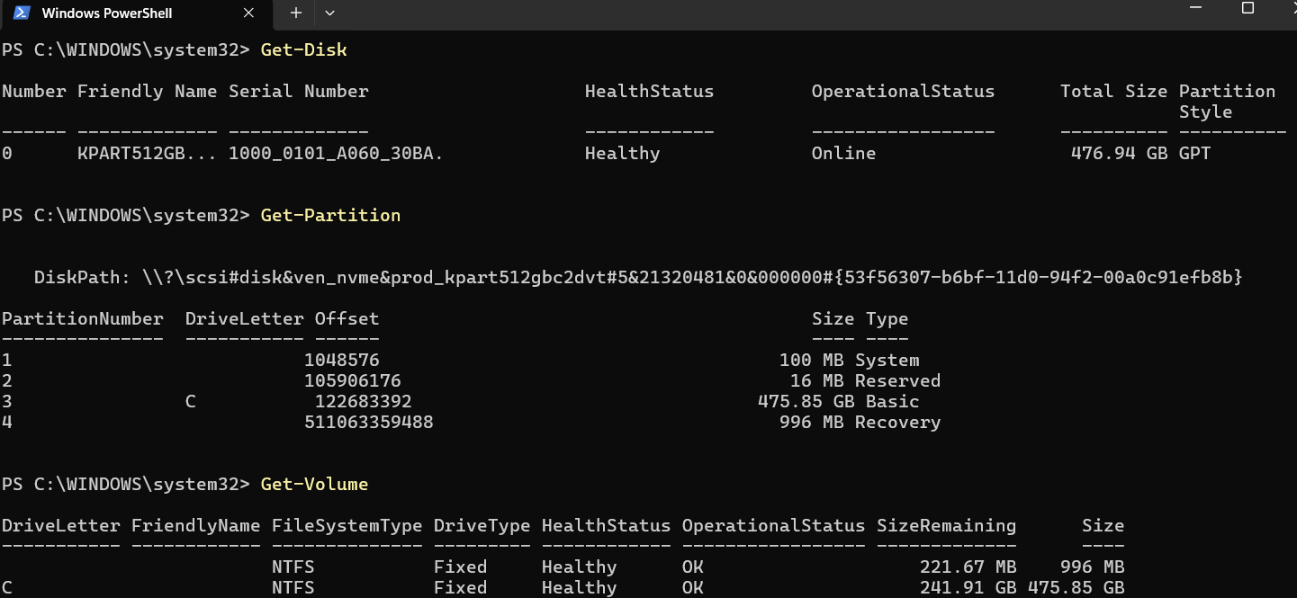
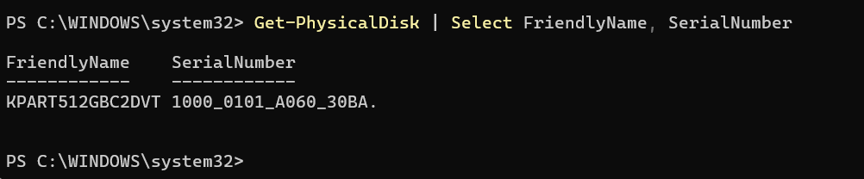
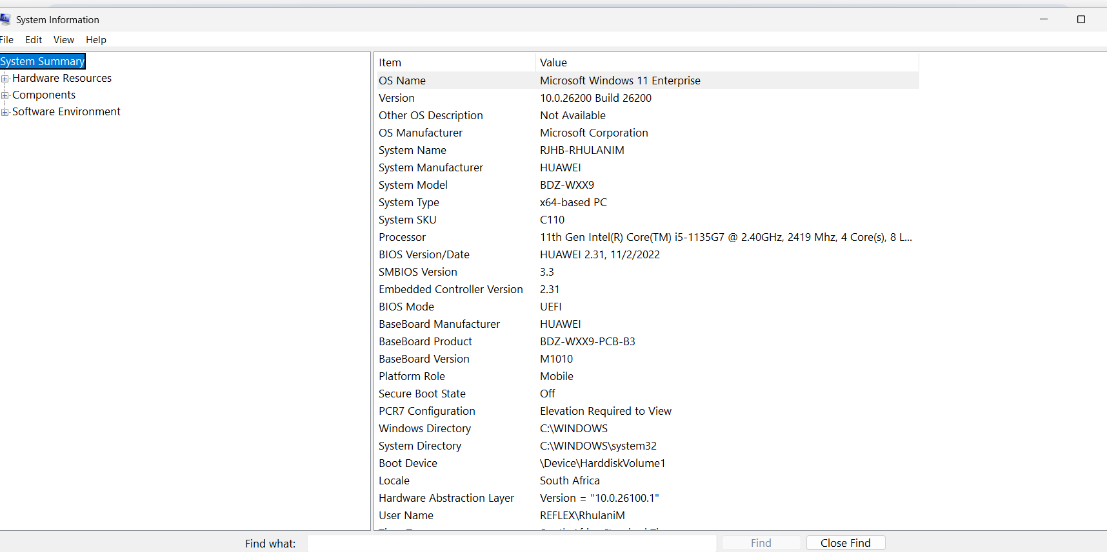
The optional WinHex analysis was not performed. However, the Get-Disk command confirmed that Disk 0 uses the GPT partition style. GPT disks use a Protective MBR and are typically associated with UEFI-based systems. This evidence was sufficient to identify the partitioning scheme.

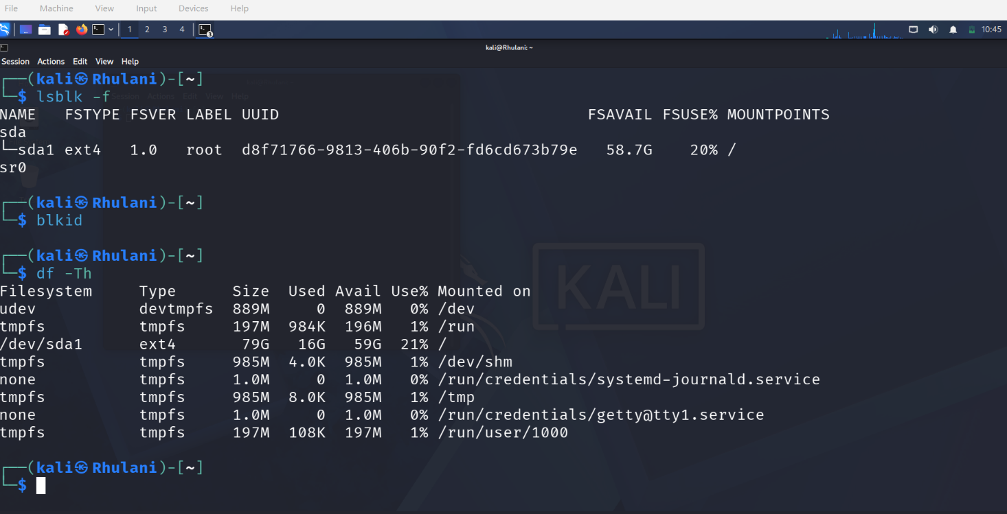

Task | Required Evidence | Student Notes / Answer
Identify partition 1 | Screenshot of partition table and command output | screenshot provided
Record partition 1 sector count | Start sector, end sector or sector count | Screenshot provided
Calculate partition 1 size | Formula and result in GB | Size (GB)=(Sector Count x 512)/1,000,000,000
Identify partition 2 | Screenshot of partition table and command output | Screenshot provided
Record partition 2 sector count | Start sector, end sector or sector count | _____
Calculate partition 2 size | Formula and result in GB | Size (GB)=(Sector Count x 512)/1,000,000,000
Compare with OS-reported size | Disk Management/Get-Volume/lsblk/df output | _____
Explain difference if any | Short explanation | GB vs GiB, rounding, reserved space, metadata

